User Authentication

URL – <http://localhost:3000/user_token>

Invalid user login details

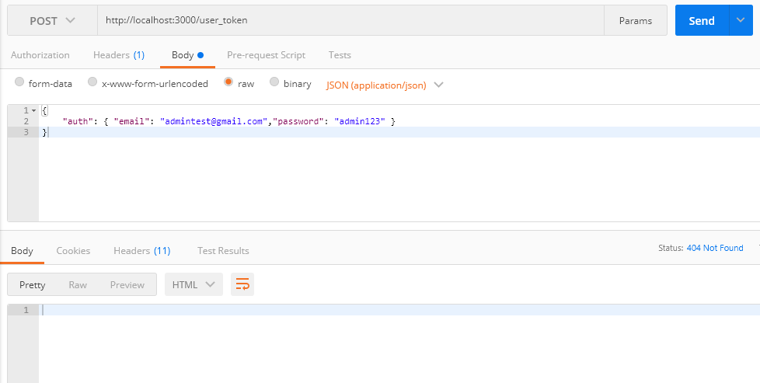

Valid user login details

Json web token is created with 1 day validity. Rest of the requests will be authenticated with jwt token.

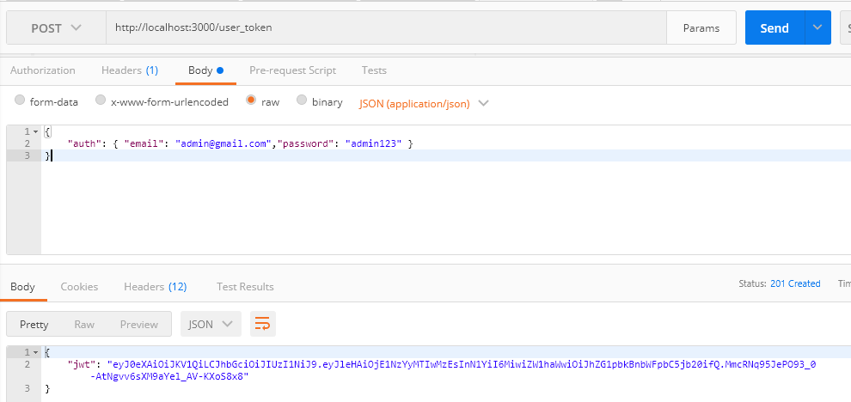

Listing all the questions irrespective of category type.

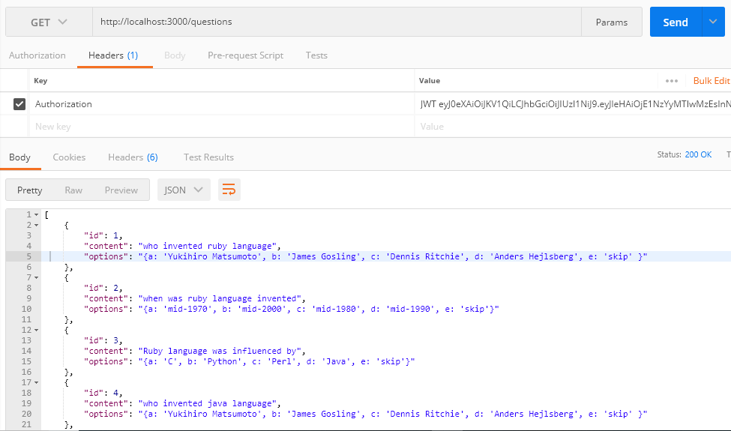

API to show the list of random questions to the user

URL - <http://localhost:3000/assessments/choose_question>

When no question presents for selected type

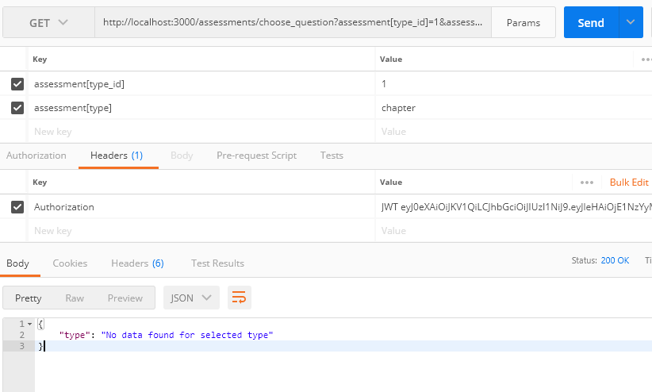

With invalid input type

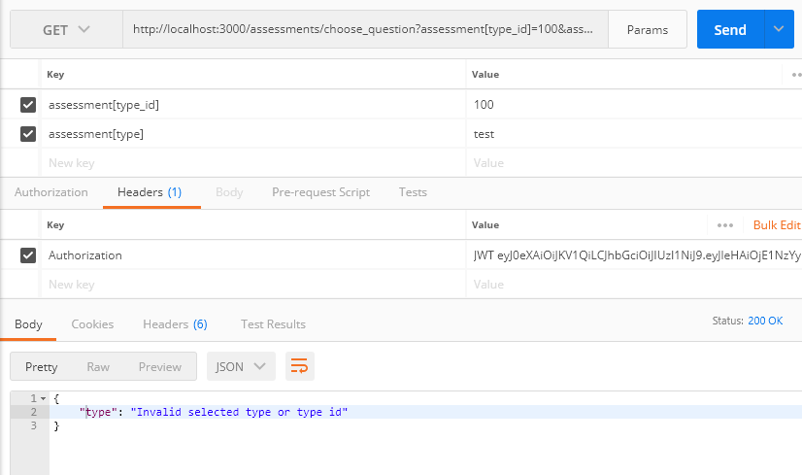

With empty inputs

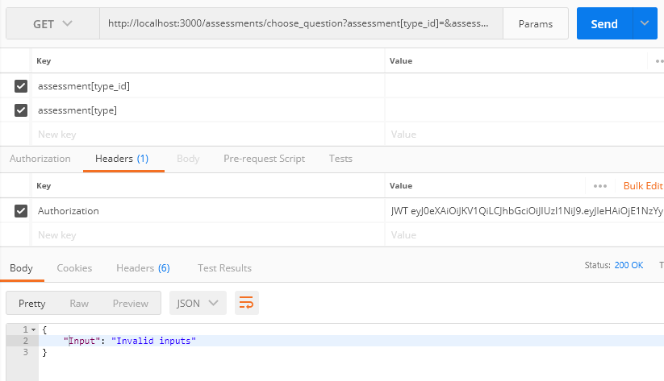

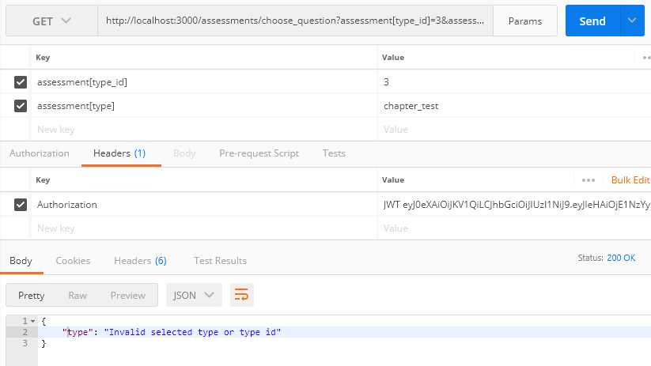

With valid chapter type

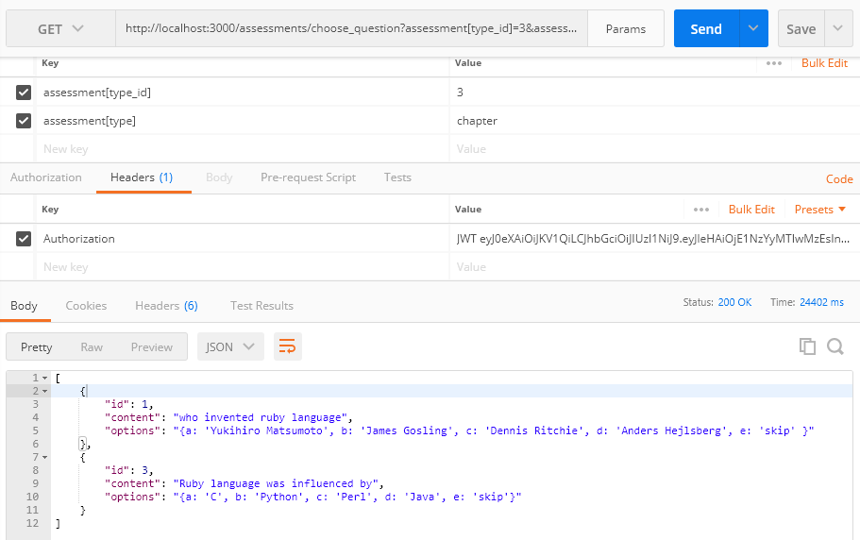

Exam has totally 5 questions, but where limited to two random questions.

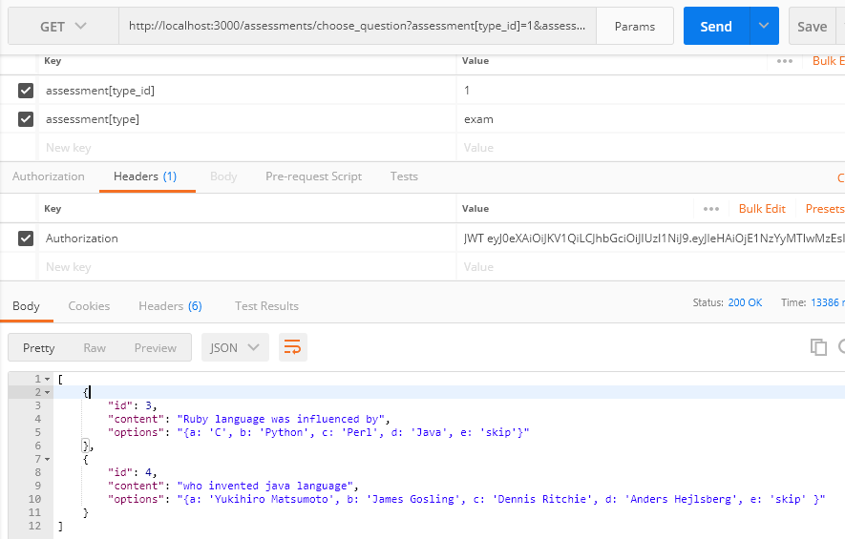

To answer any particular question.

URL - <http://localhost:3000/assessments/answer>

With invalid option

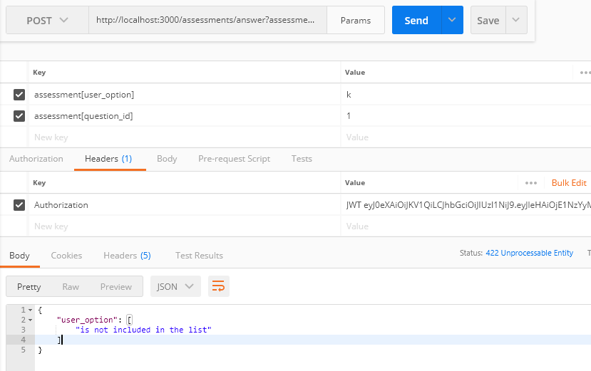

With Valid input

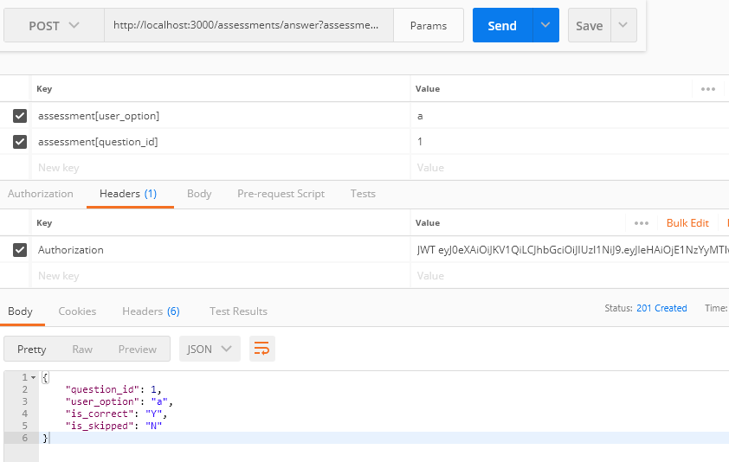

When we try to re-attend the same question

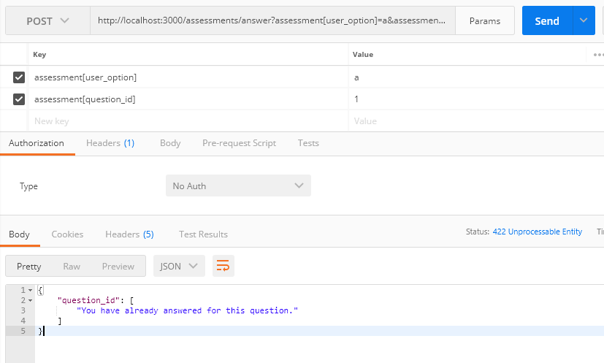

For skipped question

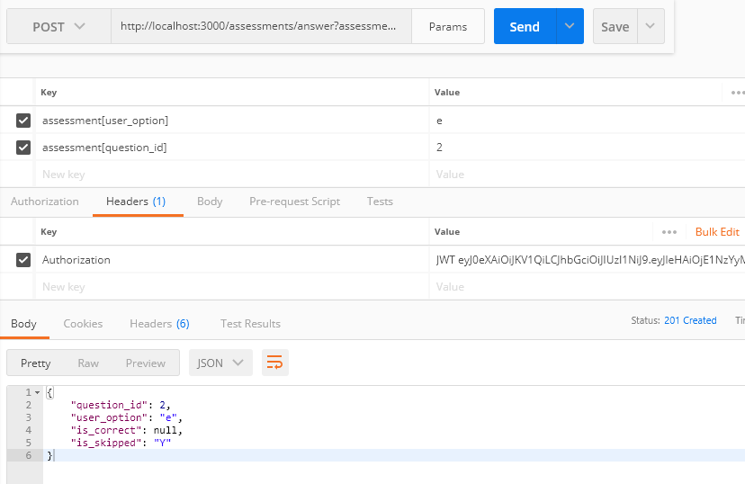

To show the result based on category type

URL - <http://localhost:3000/assessments/result>

With exam as category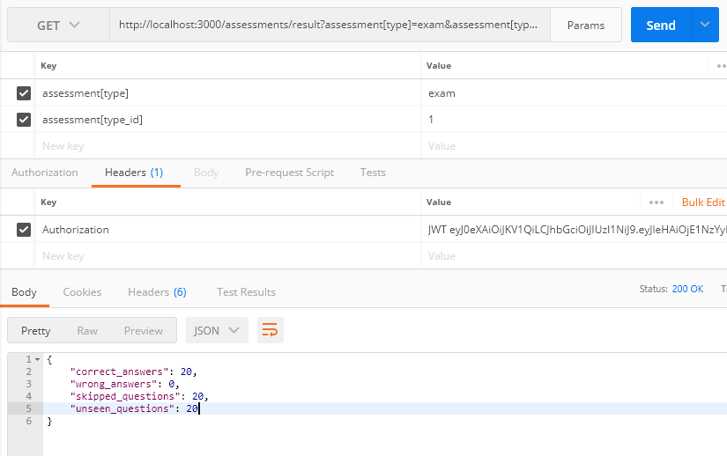

With Chapter as category

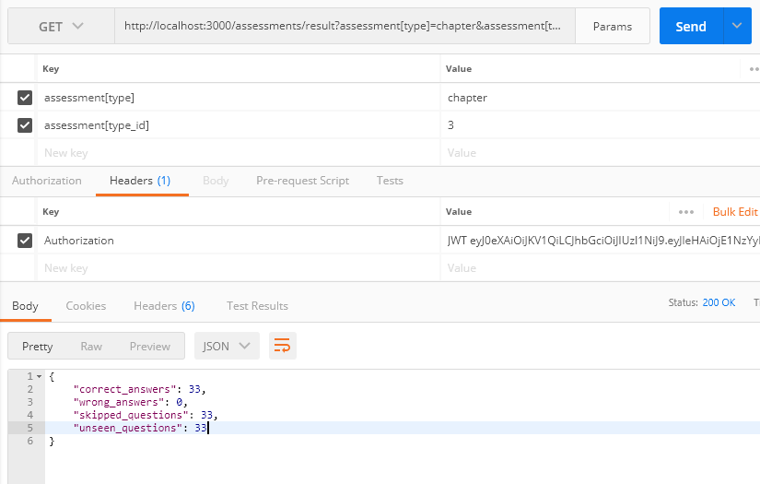

Chapter with no questions attended by user

